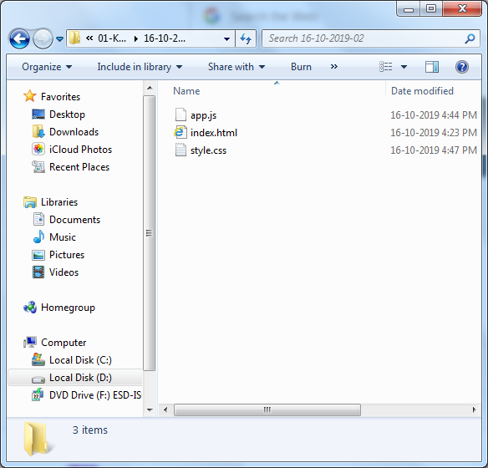

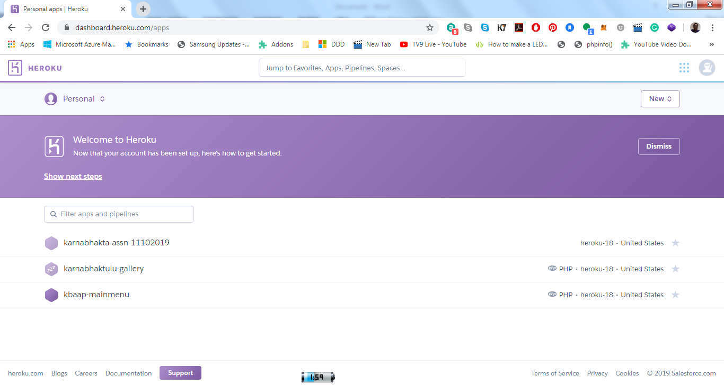

Browse this [web link](https://dashboard.heroku.com/apps) and select “New > Create new app” to proceed.

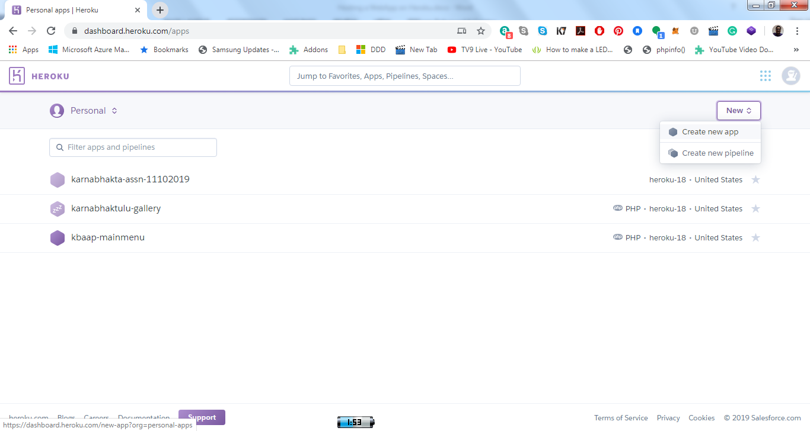

Create a new App (“mainmenu-kb-ss-ap” in this case):

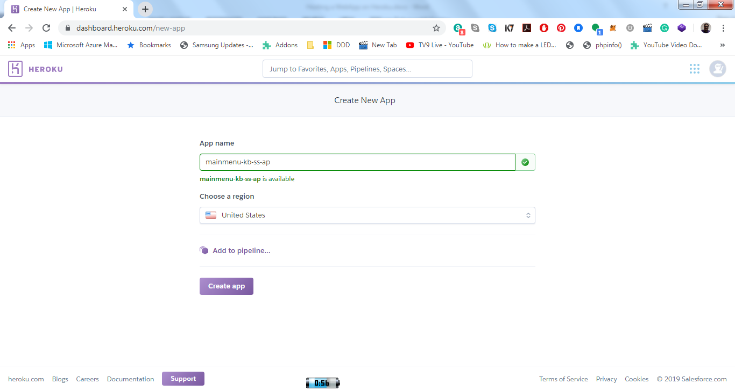

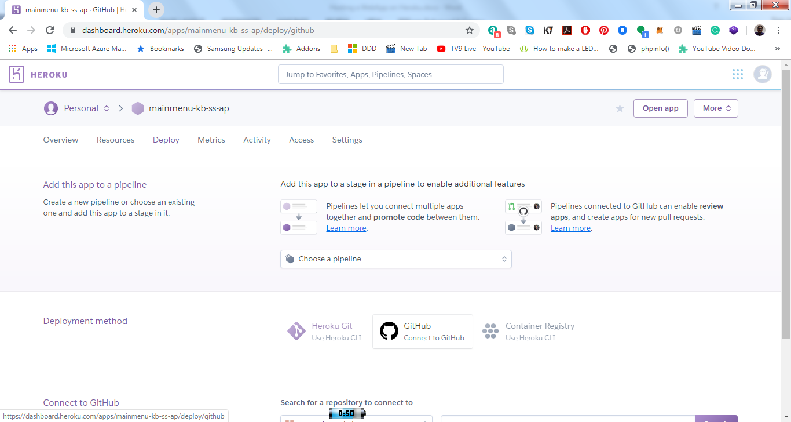

Select “GitHub” to proceed further.